# AI Face detection Demo

## Data flow

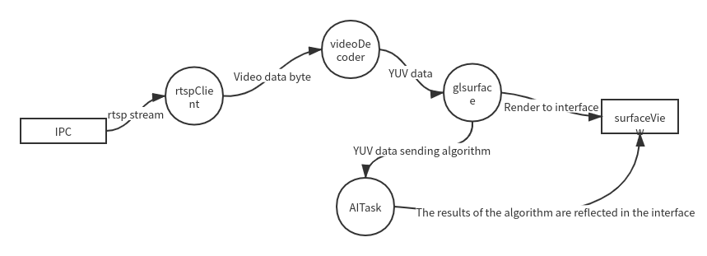

Img 1 Data flow

Video data stream: IPC provides a RTSP stream with video encoding format of h264 as video output device. After the rtspclient in the app is started, the RTSP stream is pulled, and the data is converted into a byte array and stored in the memory queue accessible by the video decoder. The video decoder decodes the video data into YUV image, sends it to glrender and renders it to the surfaceview. At the same time, the image data on glsurface is obtained and sent to the specified algorithm, and the results are also displayed on the surface view.

## Overall process

### Definition of core class

### 1. Mainactivity main activity initializes the video playing interface and initializes the AI algorithm. Display video images.

### 2. Tsvideo decoder, decode video data, do some optimization.

### 3. Tsrealtimeplayer initializes live555client, pulls RTSP stream, starts video decoder, and provides interface to control pull stream life cycle.

### 4. Myglsurfaceview custom surfaceview realizes video rendering and obtains the core class of video data sending algorithm.

### 5. Playfragment is a component for playing video and displaying recognition results. It carries myglsurfaceview and controls the life cycle of tsrealtimeplayer. The interface of drawing face frame is provided to faceinputtask for rendering results.

### Definition of core thread

1. Faceinputtask face recognition algorithm thread is responsible for returning face recognition results.

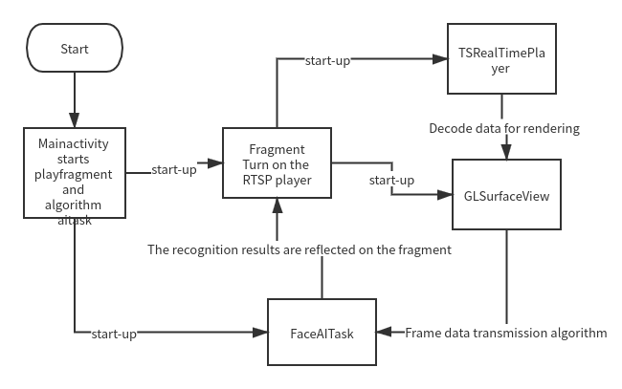

Image 2 App startup process